Lab 1: Microscopy

Objectives
- Demonstrate the correct use of a compound light microscope
- Explain the concepts of magnification
- Name the main parts of a compound light microscope
- Observe the microscopic characteristics of the main groups of microorganisms

Background
Microscopy is a fundamental tool in the field of microbiology: as a science dedicated to those organisms invisible to the naked eye, microscopes are needed to observe and study them. The first microscope was invented in the early 17th century by Zacharias Janssen of the Netherlands. Anton van Leeuwenhoek, a Dutch clerk of a dry-goods store, was the first to use a single-lens microscope to observe microorganisms in a variety of specimens, including pond water and scrapings of his teeth. Today, microscopes are widely used in scientific research, medicine, and industry to study everything from cells to crystals.

Parts of the Microscope
The brightfield microscope you will use in this exercise is composed of several parts (Fig.1).

Figure 1. Parts of the microscope
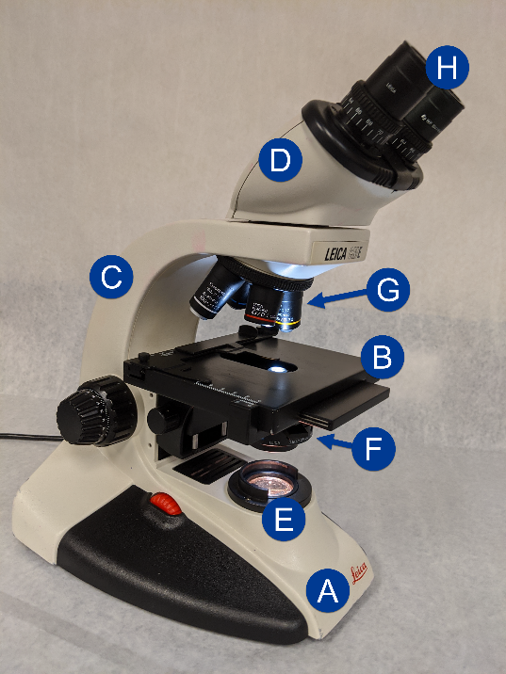
Its basic frame consists of a base (A), a stage (B) to hold the slide, an arm (C) for carrying the microscope, and a body tube (D) for transmitting the magnified image. The illuminator (E) is the light source used to illuminate the specimen, and it is in the base. Above the light is the condenser (F), which consists of several lenses that concentrate light on the slide by focusing it into a cone. The condenser has an iris diaphragm, which controls the angle and size of the cone of light. The objective lenses (G) are located on a rotating nosepiece and are used to magnify the specimen. The ocular or eyepiece lens (H) is located at the end of the tube that you look through to observe the specimen. Most modern microscopes are binocular, e.g. they have two ocular lenses.

Handling of the Microscope
When handling a microscope, it is important to follow certain rules to ensure proper use and to avoid damage to the instrument. Always be mindful of the microscope's delicate parts and handle it with care. Rules for the correct handling of the microscope include:
- Always carry the microscope with two hands, one under the base and the other grasping the arm.
- The microscope should be stored in the appropriate cabinet, with its arm pointing outside.
- Always store the microscope with the stage as far from the lenses as possible, and the scanning (4×) lens down.
- The lenses of the microscope can be cleaned only with lens paper. Any other paper, including Kleenex, may scratch the lens.
- Be sure to clean any oil residue from the lenses and the stage before putting the microscope away. When retrieving a microscope, check if it was put away correctly and notify your instructor if it was not.
- Do not twist the cable around the stage; just leave it to the side.

Focusing the Microscope
By moving the lens closer to the slide or the stage closer to the objective lens, using the coarse- or fine-adjustment knobs, one can focus the image. The larger knob, the coarse adjustment, is used for focusing with the low-power objectives (4× and 10×), and the smaller knob, the fine adjustment, is used for focusing with the high-power and oil immersion lenses. The coarse-adjustment knob moves the lenses or the stage longer distances. The area seen through a microscope is called the field of vision (FOV).
The magnification of a microscope depends on the type of objective lens used with the ocular. Compound microscopes have three or four objective lenses mounted on a nosepiece: scanning (4×), low-power (10×), high-dry (40× to 45×), and oil immersion (97× to 100×). The magnification provided by each lens is stamped on the barrel. The total magnification of the object is calculated by multiplying the magnification of the ocular (usually 10×) by the magnification of the objective lens. The most important lens in microbiology is the oil immersion lens. It has the highest magnification (97× to 100×) and must be used with immersion oil. Optical systems could be built to magnify much more than the 1000× magnification.
As you use the microscope, you will see that as magnification increases, your field of vision (FOV) will become smaller. To calculate FOV, you need to know the field number of the lens. The field number (FN) in microscopy is defined as the diameter of the area in the intermediate image plane that can be observed through the eyepiece, and it is usually written on the objective lens together with the N.A. To calculate the FOV, simply divide the FN by the total magnification used.
As you move from lower to higher magnification, you will notice that the sample will remain in focus or only minor adjustments need to be made. Parfocality refers to the property of a microscope lens where the focus remains unchanged as the magnification is changed. This makes the focusing process much easier.

Resolution
Resolution or resolving power refers to the ability of lenses to reveal fine detail or two points distinctly separated. An example of resolution involves a car approaching you at night. At first, only one light appears, but as the car nears, you can distinguish two headlights. The resolving power is a function of the wavelength of light used and a characteristic of the lens system called the numerical aperture. Resolving power is best when two objects are seen as distinct even though they are very close together. Resolving power is expressed in units of length—the smaller the distance, the better the resolving power.
$$\text{Resolving power=}\frac{\text{Wavelength of light used}}{\text{2 × numerical aperture}}$$
Smaller wavelengths of light improve resolving power. The effect of decreasing the wavelength can be seen in electron microscopes, which use electrons as a source of light. The electrons have an extremely short wavelength and result in excellent resolving power. A light microscope has a resolving power of about 200 nanometers (nm), whereas an electron microscope has a resolving power of less than 0.2 nm. The numerical aperture is engraved on the side of each objective lens (usually abbreviated N.A.). Increasing the numerical aperture (for example, from 0.65 to 1.25) improves the resolving power. The numerical aperture depends on the maximum angle of the light entering the objective lens and on the refractive index (the amount the light bends) of the material (usually air) between the objective lens and the slide. This relationship is defined by the following.
$$N.A.=N\sin{θ}$$
N = Refractive index of medium
$θ$ = Angle between the most divergent light ray gathered by the lens and the center of the lens

Figure 2. (a)
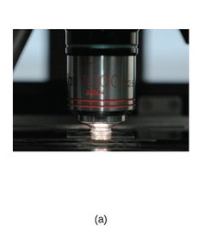

Figure 2. (b)
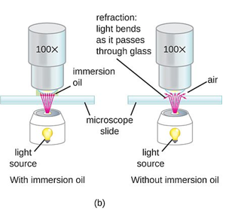
Source: Microbiology (licensed under CC BY 4.0)

As shown in Figure 2., light is refracted when it emerges from the slide because of the change in media as the light passes from glass to air. When immersion oil is placed between the slide and the oil immersion lens, the light rays continues without refraction because immersion oil has the same refractive index (N = 1.52) as glass (N = 1.52).

Lab Activity:
Observation of Microorganisms Under the Microscope

Materials
- Microscope
- Prepared microscope slides
- Immersion oil
- Facial tissue or alcohol wipes

Procedure
If you have not used the compound microscope before, proceed to Step 1 of the procedure below. If you have used the compound microscope but have NOT used the oil objective, observe all the prepared slides without oil, and then proceed to Step 8 of the procedure. Once you feel confident with using the compound light microscope, please observe the slides of the different microorganisms under different magnifications.
- Place the microscope on the bench squarely in front of you.
- Obtain a slide of algae, fungi, or protozoa, and place it in the clips on the mechanical stage.
- Adjust the eyepieces on a binocular microscope to your own personal measurements.
  - Look through the eyepieces and, using the thumb wheel, adjust the distance between the eyepieces until one circle of light appears.
  - With the low-power (10×) objective in place, cover the left eyepiece with a small card and focus the microscope on the slide. When the right eyepiece has been focused, remove your hand from the focusing knobs and cover the right eyepiece. Looking through the microscope with your left eye, focus the left eyepiece by turning the eye-piece adjustment. Make a note of the number at which you focused the left eyepiece so you can adjust any binocular microscope for your eyes.
- Raise the condenser up to the stage. On some microscopes, you can focus the condenser by the following procedure:
  - Focus with the 10× objective.
  - Close the iris diaphragm so only a minimum of light enters the objective lens.
  - Lower the condenser until you see the light as a circle in the center of the field. On some microscopes, you can center the circle of light by using the centering screws found on the condenser.
  - Raise the condenser up to the slide, lower it, and stop when the color on the periphery changes from pink to blue (usually 1 or 2 mm below the stage).
- Open the iris diaphragm until the light just fills the field.
- Adjust the contrast by changing the diaphragm opening. Diagram some of the cells on the slide under low power.
To use a minimum of light, which part of the microscope should be adjusted?
Click or tap here to enter text.
- When you have brought an image into focus with low power, rotate the turret to the next lens, and the subject will remain almost in focus. All of the objectives (with the possible exception of the 4×) are parfocal; that is, when a subject is in focus with one lens, it will be in focus with all of the lenses. When you have completed your observations under low power, swing the high-dry objective into position and focus. Use the fine adjustment.
Only a slight adjustment should be required. Why?
Click or tap here to enter text.
More light is usually needed. How can you increase the amount of light?
Click or tap here to enter text.
Again, draw the general size and shape of some cells.
Click or tap here to enter text.
- Move the high-dry lens out of position and place a drop of immersion oil on the area of the slide you are observing. Carefully click the oil immersion lens into position. It should now be immersed in the oil. Careful use of the fine-adjustment knob should bring the object into focus. Note the shape and size of the cells. Did the color of the cells change with the different lenses? Did the size of the field change? How many cells fir at higher magnification compared to lower magnification?
- After observing under oil, do NOT move the stage vertically. Rotate the objective lenses to the side (do not let the 40× touch the oil) halfway, remove the slide, insert the next one, add a drop of oil on top, and turn the oil objective back. Repeat the procedure with all slides. Be sure to wipe off the oil objective with dry lens paper thoroughly after you’re done.
- Clean prepared slides and the stage with facial tissue (Kleenex). If very dirty, use alcohol.
Note: To observe bacteria, you NEED to use the oil objective.

Report

Provide the following
- State the name of the organism observed and its taxonomical group (ex. Plasmodium, protozoan).
- Sketch a diagram of the organism at the best magnification observed (this won’t always be the highest!). Record the TOTAL magnification (objective lens magnification × ocular lens magnification). Write down any additional observations.
- Take a picture using your cell phone through the ocular lens.

Answer these questions
- Which objective is closest to the slide when it is in focus?
- Write down the correct procedure to put the microscope away.
- You are observing samples of Bacillus cells, which are 2 µm long, and yeast cells, which are 10 µm long. You are using the high-dry (40×) lens with a FN= 22 mm.
  - What will be the FOV for this lens and magnification?
  - How many Bacillus cells can you fit across the FOV?
  - How many yeast cells can you fit across the FOV?

